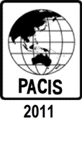
17th PACIS 2013 Doctoral Consortium
June 18-19, 2013
Seowipo KAL Hotel, Jeju Island, Korea

Nomination Form

Dissertation Title
Candidate Information
Name
Institution and Department
Email
Phone
Fax
Nominating Faculty Information
Name
Designation
Institution and Department
Email
Phone
Fax

With this nomination, I, as the nominating faculty, certify that the candidate ______________________________ is the sole ( ), the first-ranked ( ), or the second-ranked ( ) nominee for PACIS 2013 Doctoral Consortium from the _______________________ University.

